LESSON 17.
Microbiology diagnosis of infections, caused by arboviruses group (families of Togaviridae, Flaviviridae, Arenaviridae, Bunyaviridae, Reoviridae and Filoviridae) and Rhabdoviridae family
LESSON PLAN:
1. Arbovirus group. General features.
2. Togaviridae family, general properties (classification, morphology, reproduction, antigen structure, durability).
• Alphavirus genus, general properties, pathogenesis and clinical forms (Sindbis fever, Semlika forest fever). Microbiological diagnosis of alphavirus infections
3. Flaviviridae family, general properties (morphology, reproduction, persistence, classification). Microbiological diagnosis of diseases (yellow fever, dengue fever, tick-borne encephalitis, hemorrhagic fever).
4. Arenaviridae family, classification, general properties (morphology, reproduction, durability). Microbiological diagnosis of diseases caused by it (Lass fever).
5. Bunyaviridae family, general properties (morphology, reproduction, durability). Microbiological diagnosis of the diseases caused by it (Crimea-Congo hemorrhagic fever, Hantavirus pneumonia syndrome (HPS), hemorrhagic fever with renal syndrome (HFRS)).
6. Reoviridae family, general properties (morphology, reproduction, durability). Morpho-biological characteristics of rotaviruses, epidemiology, diseases caused by them, pathogenesis, microbiological diagnosis.
7. Filoviridae family, classification, general properties (morphology, reproduction, antigen structure, durability). Microbiological diagnosis of diseases caused by Marburg virus and Ebola virus
8. Rhabdoviridae family, general properties.
• General properties of the rabies virus (morphology, cultural and antigenic properties, types). Epidemiology, pathogenesis and clinical features of rabies. Microbiological diagnosis of rabies, specific prevention.

RHABDOVIRUSES

Trigger Words
Mad dog, hydrophobia, salivation, bullet-shaped virion, Negri bodies
Biology, Virulence, and Disease
ᑏ Medium size, bullet shaped, enveloped, (−) RNA genome
ᑏᑏ Encodes RNA-dependent RNA polymerase, replicates in cytoplasm
ᑏᑏAntibody can block disease
ᑏᑏVirus spreads along neurons to salivary glands and brain
ᑏᑏAntibody produced after virus reaches brain
ᑏᑏ Incubation period depends on proximity of bite to CNS and infectious dose

Epidemiology
ᑏᑏZoonosis
ᑏᑏ Reservoir in skunks, raccoons, foxes, badgers, bats (aerosols)
Diagnosis
ᑏᑏ RT-PCR, antigen detection in biopsy, presence of Negri bodies in infected cells
Treatment, Prevention, and Control
ᑏᑏ Immunization with killed vaccine after bite and antirabies immunoglobulin
ᑏᑏ Prophylaxis if job-related risk
ᑏᑏ Inactivated vaccine for pets
ᑏᑏVaccinia virus hybrid vaccine for wild animals

Unique Features of Rhabdoviruses
Bullet-shaped, enveloped, negative-sense, single-stranded RNA viruses that encode five proteins.
Prototype for replication of negative-strand enveloped viruses.
Replication in cytoplasm.

Disease Mechanisms of Rabies Virus
Rabies is usually transmitted in saliva and acquired from the bite of a rabid animal.
Rabies virus is not very cytolytic and seems to remain cell associated except in salivary gland.
Virus replicates in the muscle at the site of the bite, with minimal or no symptoms (incubation phase).
The length of the incubation phase is determined by the infectious dose and the proximity of the infection site to the CNS and brain.
After weeks to months, the virus infects the peripheral nerves and travels up the CNS to the brain (prodrome phase).
Infection of the brain causes classic symptoms, coma, and death (neurologic phase).
During the neurologic phase, the virus spreads to the glands, skin, and other body parts, including the salivary glands.
Rabies infection does not elicit an antibody response until the late stages of the disease, when the virus has spread from the CNS to other sites.
Salivary glands produce and release large amounts of virus and is the major source of contagion.
Administration of antibody can block progression of the virus and disease if given early enough.
The long incubation period allows active immunization as a postexposure treatment.
CNS, Central nervous sy stem.

Pathogenesis of rabies virus infection. Numbered steps describe the sequence of events. (Modified from Belshe, R.B., 1991. Textbook
of Human Virology, second ed. Mosby, St Louis, MO.)
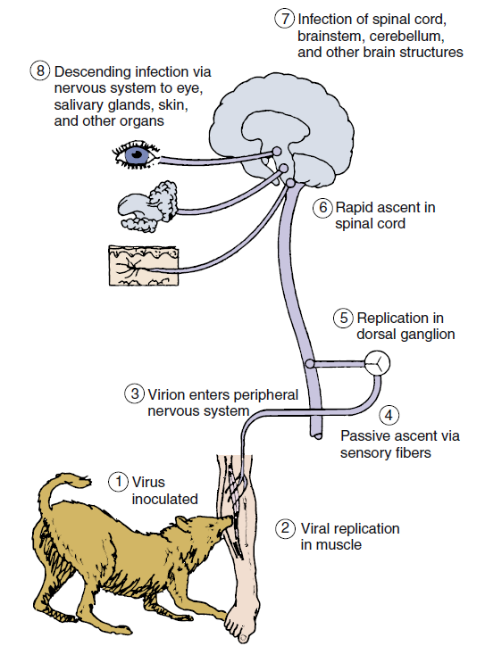

Epidemiology of Rabies Virus
Disease/Viral Factors
Virus-induced aggressive behavior in animals promotes virus spread.
Production of virus by salivary gland transmits virus in bite.
Disease has long, asymptomatic incubation period.
Transmission
Zoonosis
Reservoir: wild animals.
Vector: wild animals and unvaccinated dogs and cats.
Source of virus
Major: saliva in bite of rabid animal (including bats).
Minor: aerosols in bat caves containing rabid bats.
Rare: transplant of contaminated cornea or organ.
Who Is at Risk?
Veterinarians and animal handlers.
Person bitten by a rabid animal.
Inhabitants of countries with no pet vaccination program.
Geography/Season
Virus found worldwide, except in some island nations.
No seasonal incidence.
Modes of Control
Vaccination program is available for pets.
Vaccination is available for at-risk personnel.
Vaccination programs have been implemented to control rabies in forest mammals.
Clinical Summary
Rabies: A 3-year-old girl was found to have a bat flying in her bedroom. The bat apparently was there all night. There was no evidence of any bite wound or contact, and the bat was caught and released. Three weeks later, the child developed a change in behavior, becoming irritable and agitated. This state quickly progressed to confusion, uncontrollable thrashing about, and inability to handle her secretions. She eventually became comatose and died from respiratory arrest.

Progression of Rabies Disease

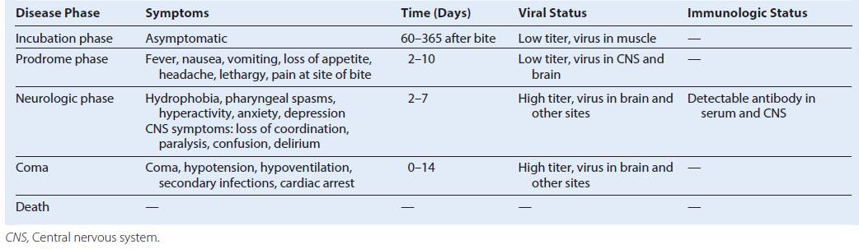

Patterns of alphavirus and flavivirus transmission. Birds and small mammals are the hosts that maintain and amplify an arbovirus, which is spread by the insect vector during a blood meal. A double arrow indicates a cycle of replication in both host (including man) and vector. “Dead-end” infections with no transmission of the virus back to the vector are indicated by the single arrow. EEEV, Eastern equine encephalitis virus; VEEV, Venezuelan equine encephalitis virus; WEEV, western equine encephalitis virus.
Arboviruses
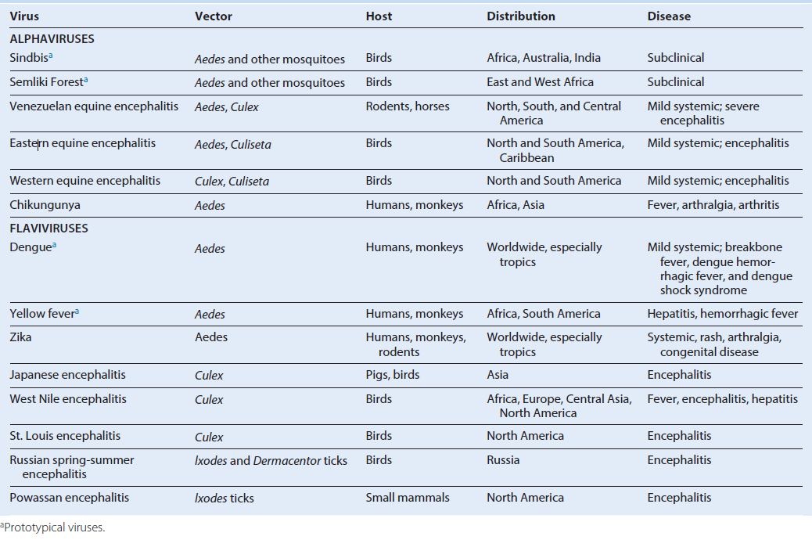

TOGAVIRUSES
Trigger Words
Arboviruses: mosquito, encephalitis
Rubella: German measles, congenital disease, rash, vaccine

Biology, Virulence, and Disease
ᑏ Small size, envelope surrounds icosahedral nucleocapsid, (+) RNA genome
ᑏᑏ Encodes RNA-dependent RNA polymerase, replicates in cytoplasm
ᑏᑏ Early and late mRNA and proteins produced
ᑏᑏVirus spreads in blood to target tissues, including neurons and brain
ᑏᑏ Antibody can block viremia and disease
ᑏᑏ Prodrome of flulike symptoms caused by interferon and cytokine response
ᑏᑏ Arboviruses: equine encephalitis viruses (WEE, EEE, VEE)
ᑏᑏ Rubella: benign childhood rash, swollen glands. Adult complications include
arthritis, encephalitis. Congenital infection: teratogenic, cataracts, deafness, microcephaly, etc.

Epidemiology
ᑏᑏ Arboviruses: zoonosis, reservoir in birds, vectors are Aedes and Culex mosquitoes
ᑏᑏ Rubella: aerosol spread, only infects humans, unvaccinated individuals at
risk, fetus at high risk

Diagnosis
ᑏᑏ RT-PCR, ELISA

Treatment, Prevention, and Control
ᑏᑏ Arboviruses: mosquito control
ᑏᑏ Live attenuated rubella vaccine at 1 year of age in MMR; booster at 4 to 6 years

FLAVIVIRUSES
Trigger Words
Arboviruses: mosquito, encephalitis, hemorrhagic diseases
Hepatitis C virus
Biology, Virulence, and Disease
ᑏᑏ Small size, envelope surrounds icosahedral nucleocapsid, (+) RNA genome
ᑏᑏ Encodes RNA-dependent RNA polymerase, replicates in cytoplasm
ᑏᑏ Neutralizing antibody can block disease
ᑏᑏ Nonneutralizing antibody promotes dengue virus infection
ᑏᑏ Cross-reactive antibodies produced against different flaviviruses
ᑏᑏ Virus spreads in blood to target tissues:for encephalitis viruses neurons and brain; for hemorrhagic viruses vasculature, liver, organs
ᑏᑏ Prodrome of flulike symptoms caused by interferon and cytokine response
ᑏᑏ Arboviruses
ᑏᑏ Encephalitis viruses: St. Louis, West Nile, Japanese encephalitis viruses
ᑏᑏ Hemorrhagic disease:
Yellow fever: jaundice, black vomit
Dengue: hemorrhagic fever, breakbone fever, dengue shock syndrome

Epidemiology
ᑏᑏ Endemic to habitat of mosquito
ᑏᑏ Arboviruses: zoonosis, reservoir in birds, vectors are Aedes or Culex mosquitoes
Diagnosis
ᑏᑏ RT-PCR, ELISA
Treatment, Prevention, and Control
ᑏᑏ Arboviruses: mosquito control
ᑏᑏ Yellow fever virus: attenuated live vaccine
Unique Features of Togaviruses and Flaviviruses
Viruses have enveloped, single-stranded, positive-sense RNA.
Togavirus replication includes early (nonstructural) and late (structural) protein synthesis.
Togaviruses replicate in the cytoplasm and bud at plasma membranes.
Flaviviruses replicate in the cytoplasm and bud at intracellular membranes.

Togaviruses and Flaviviruses
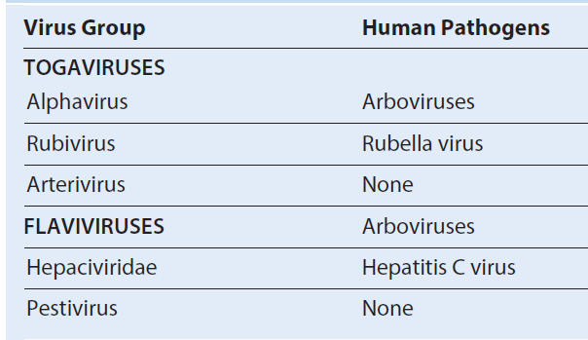

Alphavirus morphology. (B) Cross section of alpha-togavirus. The envelope is tightly associated with the capsid. (C) Cross section of flavivirus. The envelope protein surrounds the membrane envelope, which encloses an icosahedral nucleocapsid. RNA, Ribonucleic acid. (A, From Fuller, S.D., 1987. The T = 4 envelope of Sindbis virus is organized by interactions with a complementary T = 3 capsid. Cell)
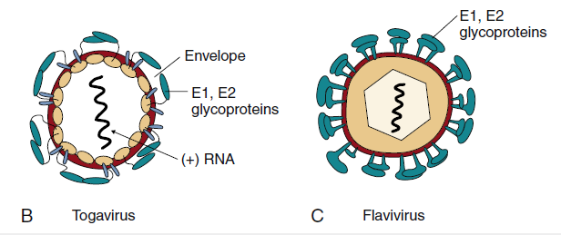

Disease Mechanisms of Togaviruses and Flaviviruses
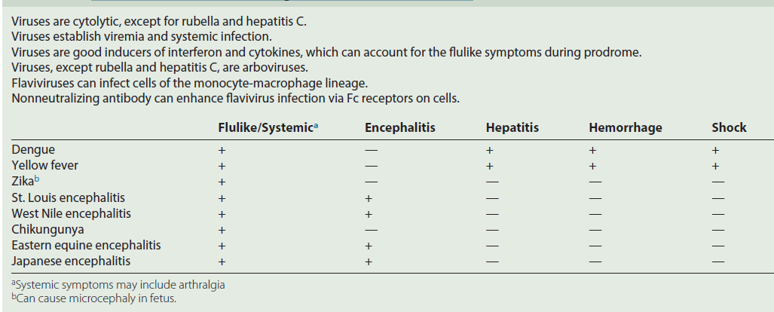

Disease syndromes of the alphaviruses and flaviviruses. Primary viremia may be associated with mild systemic disease. Most infections are limited to this. If sufficient virus is produced during the secondary viremia to reach critical target tissues, then severe systemic disease or encephalitis may result. If antibody is present (X), viremia is blocked. For dengue virus, rechallenge with another strain can result in severe dengue hemorrhagic fever (DHF), which can cause dengue shock syndrome (DSS) because of the loss of fluids rom the vasculature.

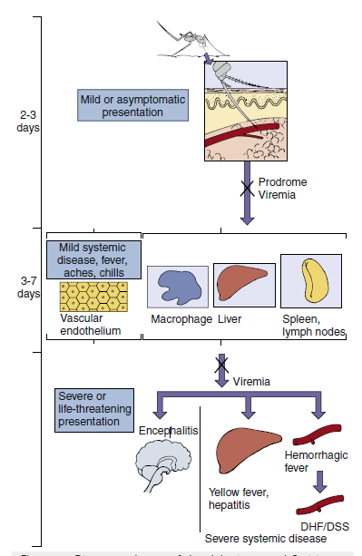

Epidemiology of Alphavirus and Flavivirus Infection
Disease/Viral Factors
Enveloped virus must stay wet and can be inactivated by drying, soap, and detergents.
Virus can infect mammals, birds, reptiles, and insects.
Asymptomatic or nonspecific (flulike fever or chills), encephalitis, hemorrhagic fever, or arthralgia.

Transmission
Specific arthropods characteristic of each virus (zoonosis: arbovirus).
Who Is at Risk?
People who enter ecologic niche of arthropods infected by arboviruses.

Geography/Season
Endemic regions for each arbovirus are determined by habitat of mosquito or other vector.
Aedes mosquito, which carries dengue and yellow fever, is found in urban areas and in pools of water.
Culex mosquito, which carries St. Louis encephalitis and West Nile encephalitis viruses, is found in forest and urban areas.
Disease is more common in summer.
Modes of Control
Mosquito breeding sites and mosquitoes should be eliminated.
Live attenuated yellow fever virus and inactivated Japanese encephalitis virus vaccines.

Spread of rubella virus within the host. Rubella enters and infects the nasopharynx and lung and then spreads to the lymph nodes and monocyte-macrophage system. The resulting viremia spreads the virus to other tissues and the skin. Circulating antibody can block the transfer of virus at the indicated points (X). In an immunologically deficient pregnant woman, the virus can infect the placenta and spread to the fetus.
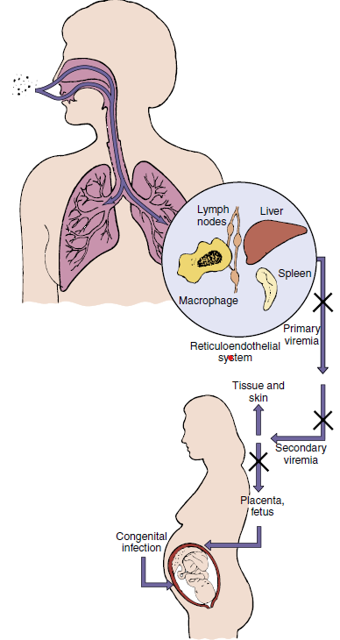

Epidemiology of Rubella Virus
Disease/Viral Factors
Rubella infects only humans.
Virus can cause asymptomatic disease.
There is one serotype.
Transmission
Respiratory route
Who Is at Risk?
Children: mild exanthematous disease.
Adults: more severe disease with arthritis or arthralgia.
Fetus <20 weeks: congenital defects.
Modes of Control
Live attenuated vaccine administered as part of the measles mumps-rubella vaccine.

Time course of rubella disease. Rubella production in the pharynx precedes the appearance of symptoms and continues throughout the course of the disease. The onset of lymphadenopathy coincides with the viremia. Fever and rash occur later. The person is infectious as long as the virus is produced in the pharynx. (Modified from Plotkin, S.A., Orenstein, W.A., Offit, P.A., 2008. Vaccines, fifth ed. Saunders, Philadelphia, PA.)
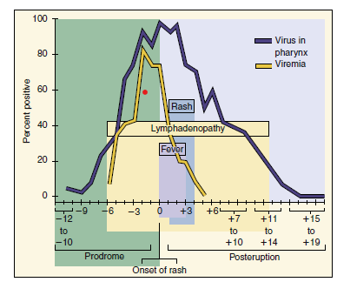

Prominent Clinical Findings in Congenital Rubella Syndrome
Cataracts and other ocular defects
Heart defects
Deafness
Intrauterine growth retardation
Failure to thrive
Mortality within the first year
Microcephaly
Mental retardation

Clinical Summaries
West Nile encephalitis: During August, a 70-year-old man from a swampy area of Louisiana developed fever, headache, muscle weakness, nausea, and vomiting. He had difficulty answering questions. He progressed into a coma. Magnetic resonance imaging results show no specific localization of lesions (unlike in herpes simplex virus encephalitis). His disease progressed to respiratory failure and death. His 25-year-old niece, living next door, complained of sudden onset of fever (39° C [102.2° F]), headache, and myalgias, with nausea and vomiting lasting 4 days. (See website https://doi.org/10.3810/pgm.2003.07.1456).
Yellow fever: A 42-year-old man had fever (103° F), headache, vomiting, and backache that started 3 days after returning from a trip to Central America. He appeared normal for a short time, but then his gums started to bleed; he had bloody urine and vomited blood; and he developed petechiae, jaundice, and a slower and weakened pulse. He started to improve 10 days after the onset of disease.
Rubella: A 6-year-old girl from Romania developed a faint rash on her face, accompanied by mild fever and lymphadenopathy.
Over the next 3 days, the rash progressed to other parts of the body. She had no history of rubella immunization.

BUNYAVIRUSES
Trigger Words
Arboviruses: mosquito, encephalitis
Hantaviruses: rodent, hemorrhagic disease

Biology, Virulence, and Disease
ᑏ Medium size, enveloped, (−) segmented RNA genome
ᑏᑏ Encodes RNA-dependent RNA polymerase, replicates in cytoplasm
ᑏᑏ Antibody can block disease
ᑏᑏ Virus spreads in blood to tissues, neurons, and brain
ᑏᑏ Prodrome of flulike symptoms caused by interferon and cytokine response
ᑏᑏ Encephalitis: La Crosse, California encephalitis
ᑏᑏ Hantaviruses: pulmonary syndrome

Epidemiology
ᑏᑏ Encephalitis viruses: zoonosis, reservoir in birds, vector is the mosquito
ᑏᑏHantavirus: inhalation of aerosols from rodent urine or feces
Diagnosis
ᑏᑏ RT-PCR, ELISA
Treatment, Prevention, and Control
ᑏᑏArboviruses: mosquito control
ᑏᑏHantaviruses: rodent control

ARENAVIRUSES
Trigger Words
ᑏᑏ Ribosomes in virion, rodent, Lassa fever virus, hemorrhagic disease, LCM virus, meningitis

Biology, Virulence, and Disease
ᑏᑏMedium size, enveloped, (−) segmented RNA genome
ᑏᑏNonfunctional ribosomes in virion
ᑏᑏ Encodes RNA-dependent RNA polymerase, replicates in cytoplasm
ᑏᑏAntibody can block disease
ᑏᑏVirus spreads in blood to tissues, neurons, and brain
ᑏᑏ Prodrome of flulike symptoms caused by interferon and cytokine response
ᑏᑏ LCM virus: meningitis
ᑏᑏ Lassa fever: hemorrhagic fever
Epidemiology
ᑏᑏ Inhalation of aerosols from rodent urine or feces
ᑏᑏ LCM virus: worldwide
ᑏᑏ Lassa fever: Africa
Diagnosis
ᑏᑏ RT-PCR, ELISA
Treatment, Prevention, and Control
ᑏᑏ Rodent control

Unique Features of Bunyaviruses
There are at least 200 related viruses in five genera that share a common morphology and basic components.
Virion is enveloped with three (L, M, S) negative-sense ribonucleic acid nucleocapsids but no matrix proteins.
Virus replicates in the cytoplasm.
Virus can infect humans, animals, and arthropods.
Virus in an arthropod can be transmitted to its eggs.

Notable Bunyaviridae Generaa

Disease Mechanisms for Bunyaviruses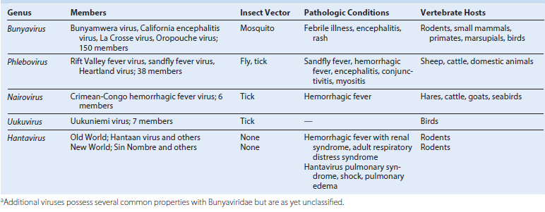

Virus is acquired from an arthropod bite (e.g., mosquito).
For hantaviruses, the virus is acquired from rodent urine or feces.
Initial viremia causes flulike symptoms.
Establishment of secondary viremia may allow virus access to specific target tissues that define the disease, including the central nervous system, organs, and vascular endothelium.
Viral and immunopathogenesis causes tissue disruption.
Antibody is important in controlling viremia; interferon and cell-mediated immunity may prevent the outgrowth of
infection and contribute to disease.

Epidemiology of Bunyavirus Infections
Disease/Viral Factors
Arboviruses able to replicate in mammalian and arthropod cells.
Arboviruses able to pass into ovary and infect arthropod eggs, allowing virus to survive during winter.
Transmission
Arboviruses, via arthropod’s blood meal; California encephalitis group, Aedes mosquito;
Aedes mosquitoes are aggressive daytime feeders and live in forests.
Aedes mosquitoes lay eggs in small pools of water trapped in places such as trees and tires.
Hantavirus: transmitted in aerosols from rodent urine and feces and by close contact with infected rodents.
Who Is at Risk?
People in habitat of arthropod or rodent vector.
California encephalitis group: campers, forest rangers, woodsmen.
Geography/Season
Disease incidence correlates with distribution of vector.
Disease more common in summer.
Modes of Control
Elimination of vector or vector’s habitat.
Avoidance of vector’s habitat.

Clinical Summary
Lassa fever: Approximately 10 days after returning from a trip to visit family in Nigeria, a 47-year-old man developed flulike symptoms with a higher than expected fever and malaise. The disease got progressively worse, and after 3 days, the patient developed abdominal pain, nausea, vomiting, diarrhea, pharyngitis, bleeding gums, and began vomiting blood. He developed shock and then died.

Arboviruses and Zoonoses
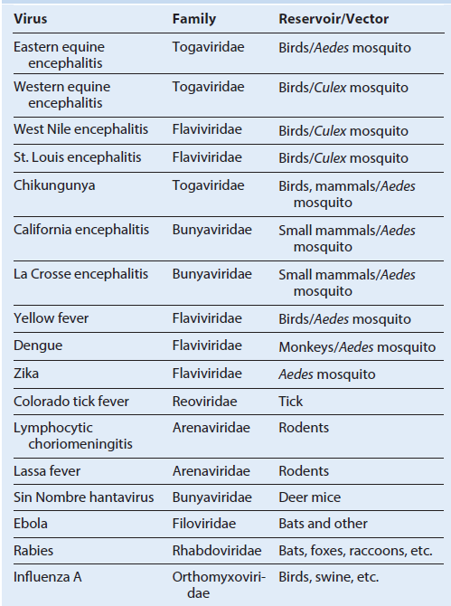

REOVIRUSES
Trigger Words
Fecal-oral, infantile diarrhea, doubledouble (capsid and double-stranded segmented RNA genome), oral vaccine

Biology, Virulence, and Disease
ᑏ Medium size, double capsid, doublestranded segmented RNA genome
ᑏᑏCapsid resistant to inactivation
ᑏᑏ Encodes RNA-dependent RNA polymerase, replicates in cytoplasm
ᑏᑏ Each segment encodes one or two proteins
ᑏᑏMixed infection results in genetic mixing of segments: reassortment
ᑏᑏ Rotavirus induces cholera-type diarrhea
ᑏᑏOne of the most serious causes of diarrhea in young children
ᑏᑏColorado tick fever, zoonosis, dengue-like disease with rash

Epidemiology
ᑏᑏ Rotavirus
ᑏᑏWorldwide and ubiquitous, occurs year round
ᑏᑏ Fecal-oral spread, very contagious, infants at risk for serious disease

Diagnosis
ᑏᑏ ELISA for virus in stool

Treatment, Prevention, and Control
ᑏᑏ Treatment: supportive rehydration
ᑏᑏ Prevention: oral live vaccines administered at 2, 4, and 6 months of age
ᑏᑏControl: handwashing and good Hygiene

Reoviridae Responsible for Human Disease
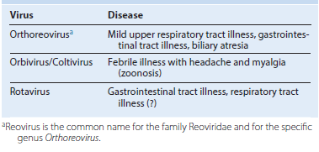

Unique Features of Reoviridae
Double-layered or triple-layered capsid virion (60 to 80 nm) has icosahedral symmetry containing 10 to 12 (depending on the virus) unique double-stranded genomic segments
(double:double virus).
Virion is resistant to environmental and gastrointestinal conditions (e.g., detergents, acidic pH, drying).
Rotavirus and orthoreovirus virions are activated by mild proteolysis to intermediate/infectious subviral particles, increasing their infectivity.
Inner capsid contains a complete transcription system, including RNA-dependent RNA polymerase and enzymes for 5′ capping and polyadenylate addition.
Viral replication occurs in the cytoplasm. Double-stranded RNA remains in the inner core.
Inner capsid aggregates around (+) RNA and transcribes (−) RNA in the cytoplasm.
Rotavirus-filled inner capsids bud into the endoplasmic reticulum, acquiring its outer capsid and a membrane, which is then lost.
Virus is released by cell lysis.

Schematic of rotavirus. Descriptions of the viral proteins. dsRNA, Double-stranded ribonucleic acid.
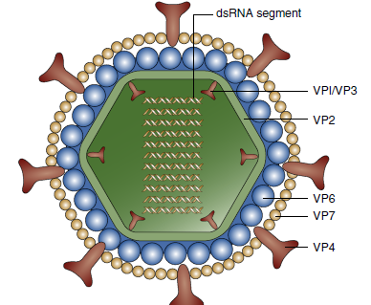

Functions of Rotavirus Gene Products
Replication of rotavirus. Rotavirus virions can be activated by protease (e.g., in the gastrointestinal tract) to produce an intermediate/infectious subviral particle (ISVP). The virion or ISVP binds, penetrates the cell, and loses its outer capsid. The inner capsid contains the enzymes for messenger ribonucleic acid (mRNA) transcription using the (±) strand as a template. Some mRNA segments are transcribed early, and others are transcribed later. Enzymes in the virion cores attach 5′-methyl capped guanosine (*G) and 3′-polyadenylate sequence (poly A [AAA]) to mRNA. (+) RNA is mRNA and is also enclosed into inner capsids as a template to replicate the ± segmented genome. VP7 and NSP4 are synthesized as glycoproteins and expressed in the endoplasmic reticulum. The capsids aggregate and “dock” onto the NSP4 protein in the endoplasmic reticulum, acquiring VP7 and its outer capsid and an envelope. The virus loses the envelope and leaves the cell on cell lysis.

Disease Mechanisms of Rotavirus
Virus is spread primarily by the fecal-oral route.
Cytolytic and toxin-like action on the intestinal epithelium causes loss of electrolytes and prevents reabsorption of water.
Disease can be significant in infants <24 months, but can be asymptomatic in adults.
Large amounts of virus are released during the diarrheal phase.

Epidemiology of Rotavirus
Disease/Viral Factors
Capsid virus is resistant to environmental and gastrointestinal conditions.
Large amounts of virus are released in fecal matter.
Asymptomatic infection can result in release of virus.
Transmission
Virus is transmitted in fecal matter, especially in day-care settings.
Respiratory transmission may be possible.
Who Is at Risk?
Rotavirus Group A
Infants <24 months of age: at risk for infantile gastroenteritis with potential dehydration.
Older children and adults: at risk for mild diarrhea.
Undernourished people in underdeveloped countries: at risk for diarrhea, dehydration, and death.
Rotavirus Group B (Adult Diarrhea Rotavirus)
Infants, older children, and adults in China: at risk for severe gastroenteritis.
Geography/Season
Virus is found worldwide.
Disease is more common in autumn, winter, and spring.
Modes of Control
Handwashing and isolation of known cases are modes of control.
Live vaccines use attenuated human or bovine reassorted rotavirus.

